

**Strategic ICT & eBusiness Implementation**

**Master’s in data Analytics**

**Assessment Project**

**20th April 2019**



###### Team Members

|  |  |  |
| --- | --- | --- |
| Name & Contribution |  | NCI Student Number |

Smit Jain = 25% x18135340

Saptarshi Das = 25% x18127355

Ankit Singh = 25% x18127321

Suraj Pandey = 25% x18130399

Table of Contents

**ABSTRACT** 3

**1. Background** 4

**1.1 Organization Background** 4

**1.2 Mission** 4

**2. Infrastructure** 5

**3. Strategy** 7

**3.1 Strategy overview** 7

**3.2 Strategies** 7

**4. System Design** 9

**4.1 System Functionality** 9

**4.2** **Process Diagrams** 10

**4.3** **Wireframes** 12

**5. Database Design** 14

**5.2 Entity-Relationship Diagram:** 15

**5.3 Entity-Relationship Diagram:** 15

**6.** **Implementation of architecture** 16

**6.1** **Accounts** 16

**6.2** **Products** 18

**6.3** **Orders** 20

**6.4** **Cases** 22

**7.** **Screenshots from salesforce** 25

**7.1** **Visualforce pages** 25

**7.2** **Apex classes** 30

**7.3** **Apex class code** 31

**8.** **Test Data** 36

**9.** **Reports and Management Dashboards** 41

**9.1** **Operational Reports** 41

**9.1.1** **Customer report** 41

**9.1.2** **Revenue report** 42

**9.1.3** **Cases Logged report** 43

**9.2** **Dashboard** 44

**10.** **Conclusion & Future Prospects** 45

**11.** **References** 46

**12.** **Bibliography** 46

# **ABSTRACT**

The concern for the analysis of data has increased severely due todata proliferation. Data analysis is now a matter of serious concern whether it’s a Product based business or a Service based. For any business to succeed, it needs a good relationship with its customers. As it is said ‘It is the customers who drive the business to its peak’, Customer relationship is one of the most important factors while starting and handling a business. CRM salesforce i.e. Customer Relationship Management Salesforce handles/manages all the customer relations of an organisation efficiently. Prior to CRM salesforce, most of the customer relationship work was done manually which required a lot of man power along with abundant time and effort. CRM salesforce makes this whole process automated and efficient. Salesforce is an all in one hub when it comes to managing the customers of a business.

**Business idea**: In this technologically advanced era, most of the services and industries are running on power. Due to the latest advancements like IOT, Automation and AI, every business Industry irrespective of its domain is consuming a lot of power and due to this the non-renewable forms of energy are being exhausted. Scientists have predicted that in the near future 2050, we will be out of non-renewable forms of energy and to overcome this major crisis the world should start using renewable forms of energy wherever it is possible to. There are different renewable forms of energy on this planet, in which the most powerful and available would be Solar energy. Solar energy i.e. energy created from the solar rays is a powerful yet easily available energy form. Photovoltaic energy gathered from the sun rays can be even used to drive buses, cars and trains apart from heating purpose which is the reason solar energy is one the most discussed topic in the world right now. Solar energy is being utilised efficiently in different countries of the world, China being the number 1. India is also one of the fastest growing solar Industry in the world as the solar Industry has quadrupled in the last four years i.e. 2013-2017 as per (<https://www.finder.com/uk/nation-most-solar-power>). As china and India are neighbouring countries situated in the same Asian subcontinent, they receive sunlight all the year round in most of their regions. So, opening and running a solar related business would be a really good Idea.

Keeping all the above aspects in mind, Brink Construction was established by a young entrepreneur in the year 2015. It deals with solar products and their installations as per customer requirement. The organisation has seen a good growth since it has been established and seeing the growth it has made in the recent years, the owner wanted to expand it by opening more offices in different states. The major issue that they are facing is the customer management and retention. As the man power is limited and costly, the owner wanted an automated customer/order management system. We would be implementing CRM salesforce on the current workflow of the business to resolve this major issue.

**Business requirement:** To manage the above business system, we have used Salesforce to integrate the whole business process under one roof by collecting customer data, storing all products and services related information and their prices. This data assists both in improving the overall business and making better business decisions by making better analysis. All these improvements directly increase the overall profit for the organisation.

# **1.** **Background**

## **1.1 Organization Background**

Brink Construction is a company specialized in providing world-class solar power systems for making a positive impact in businesses, government facilities, and educational institutions etc and making sure that they are delivered on time and on budget. It also specializes in providing solar solutions and products like solar lamps, solar lights, solar pumps, solar inverters and solar-powered battery. It helps the end user to save a huge amount of money just by installing the solar system once, hence it is a one-time investment with a massive ROI.

Established in the year 2015, this company has been showing fast growth thereafter. For best quality and customer experience, the company gathers the hardware required for installation of the Solar Power solutions from the giants in the solar business-like TATA SOLAR POWER Ltd. and various other widely popular manufacturers of India. As solar energy solutions are gaining popularity at a good pace, these types of equipment are also in high demand in the Indian market.

Brink Construction has made a commitment to enable Solar power everywhere and make the power of sun available to people around the country easily and efficiently. One of the major benefits of using solar energy is that it is subsidized in India and has led to a huge demand for solar power solutions.

## **1.2 Mission**

Our company has a motto to cope up with the continuously changing climate and the scarcity of electricity by providing solar power solutions.

With the decrease in solar prices, production capacity increases leading to industrial innovation. The factor that gives an edge to solar energy over traditional models is its scalability and easy deployment process.

# **2. Infrastructure**

**2.1 The rationale for selecting Infrastructure**

Solar power energy is one of the cleanest sources of all renewable energies available on earth. With about 300 clear days annually, India is considered quite efficient for using this energy. Utility prices of the electricity are increasing every year.

A solar power system is very pocket-friendly, and the investment done for the setup pays back in few years and additionally, it adds value to the building where it is installed. Utility prices of the electricity are increasing rapidly year by year. Hence, solar power helps you save a few bucks while paying electricity bills.

Solar is an environmentally responsible technology. Unlike fossil fuels, solar energy is environmentally responsible as it does not emit pollutants which cause harm to humans and the environment.

Hence, the Solar Power must be made more available and brought to the customer's attention. Most of the business for the organization is based on the number of queries made for the Solar Power grids and based on the availability and shipping time, the deals are made. Hence a Customer Relationship Management (CRM) is of the dire need to manage all the transactions and to avoid any foreseen delays.

A CRM system that we are going to establish will be managing all the queries sent by the customers. Once the customer places a new order, upon the availability of the stock, the products available in the inventory will be released and transported to the installation site.

This system will enable the company to manage all the business transactions easily and swiftly, which will help the company to reach new heights and make a greater profit.

**2.2 Benefits and Risks of Infrastructure selected**

**2.2.1 Benefits**

Currently, there is no automated process in place in the organization and all the business transactions are based on traditional methods. With the implementation of the CRM, the customers will be able to place all the orders, raise a service request, and arrange a call back from customer service all at one place.

For any assistance required or any issues, the customer can request for assistance on the portal.

The customer can get the work done virtually, and his physical presence is not required. The installation team will reach the proposed site and complete the installation.

**2.2.2 Risks**

The business is a continuously running process which cannot take a moment of halt for any technical fault to the CRM application. In those circumstances, the traditional method will have to be used for the business to continue unhampered.

At the time of integration of business with CRM, there are chances of having a few glitches which may impact the business. Hence an overlap of both traditional method and CRM must be in place for some time to avoid any chances of possible loss.

The biggest risk associated with CRM sales force is Privacy and Security. If the account for any salesforce staff or user is compromised, then there can be a data breach and private and confidential information may get leaked. The account can also be hacked by a hacker and private customer data can get lost which can lead to loss of business.

# **3. Strategy**

## **3.1 Strategy overview**

We Aim to generate profit above market levels. Civil engineer and contractor Aayush Jain realized the need to expand the business into the solar market. Realizing this expansion as a way of expanding and diversifying his business, he launched Brink Constructions, which is now one of the hottest solar organizations in central India due to its efficient and reliable products and services.

The strategy for any organization begins with marketing, whether it is solar cells or pens, a good organization requires good marketing strategy. When it comes to the best marketing strategy, the most important thing to keep in mind is to think like a customer i.e. stepping inside the customer's shoes and realizing what a customer wants and then decide the products and services accordingly. The important things to discuss would be – What is in for our customers and how will they benefit from our product?

For Solar, the main pain points are –

Electricity and other utility bills

The increasing cost of fuels

Pollution due to emissions and global warming

## **3.2 Strategies**

**Strategy #1**: Focusing the advertising on educating the targeted customers about the benefits of solar power energy i.e. advertising about solar benefits on pricing when customers receive their electricity and utility bills.

**Strategy #2**: Talking to targeted customers about the long-term costs of fuel supplies and utility bills. Coal, gas, fuel and oil come with a diminishing supply and increasing demand which leads to increased costs. Solar energy, on the other hand, would be getting easier and cheaper as the demand increases.

**Strategy #3**: Use the power of community and referral. If you are on-site to install solar for any customer, leave flyers of your organization to the neighbouring houses. Ask your customers to refer your organization and products to their friends and neighbours.

**Strategy #4**: Get to know your customer. If you do not know the requirement and solar knowledge of your customers, then ask. You need to think like a customer to be successful in customer retention.

**Strategy #5**: Know the in and out of the Solar Industry. Read magazines and websites of the leading giants in the solar business worldwide and build your own organizational standards surrounding that information.

**Strategy #6**: Be clear about the products and services you are going to provide. Be clear in differentiating between your products and services and also be clear about your long-term service plan and track record.

**Strategy #7**: Entertain and engage your customers, build trust so that they can remember you for providing them with valuable information on solar Industry and products.

# **4. System Design**

## **4.1 System Functionality**

**Acquiring customers** –

As this organization is working towards solar services and products, hence we need to know which product is in maximum demand or is most useful amongst the customers. For this, the awareness of Solar Power and its benefits must be marketed.

Additionally, to build a huge customer base we need to keep a record of all the customer queries that land up on the CRM portal for any product or service-related query. Even if the customer is not a potential buyer, we will save his/her data and assign a representative to get back to them with all the information about solar services and benefits along with our prices and discounts.

**Request made by a customer –**

Let us discuss the process flow of the order requests made by the customers on the page.

First, the customer opens the page and makes a new order request. An order is placed and subsequently an email is triggered to both the customer and the third-party team for the installation of the product.

After the request is made, it goes to the Inventory to check whether the product requested is available or not. If it is not available, then it throws up an error saying there’s insufficient stock in the inventory. If the product is available and ready to ship, the order is confirmed, and the customer receives an order confirmation email. After that the customer support team gets in touch with the customer and provides him further details of when the product will be shipped. The installation is totally handed by the third-party team. So, once the customer places an order, an email is triggered to the third-party team as well.

The request goes to the order delivery team and a delivery ID is assigned to the order.

After the product gets delivered, the customer pays the amount only in cheque since the amount is very huge and it isn’t safe to pay in cash or take risk by transferring the amount online.

## **Process Diagrams**

The process diagram of the proposed business process is below:

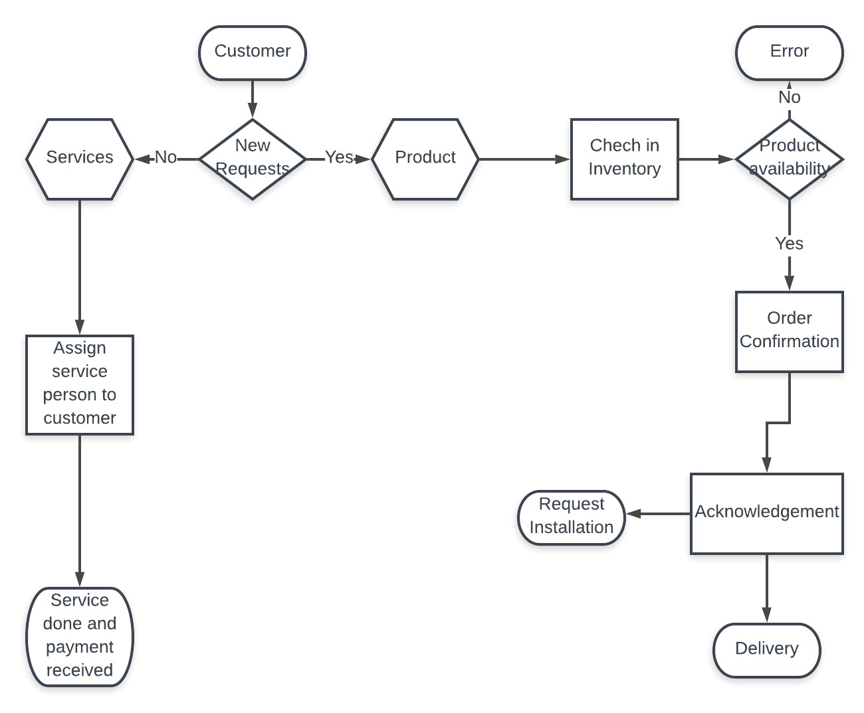

A more defined process flow according to different views:

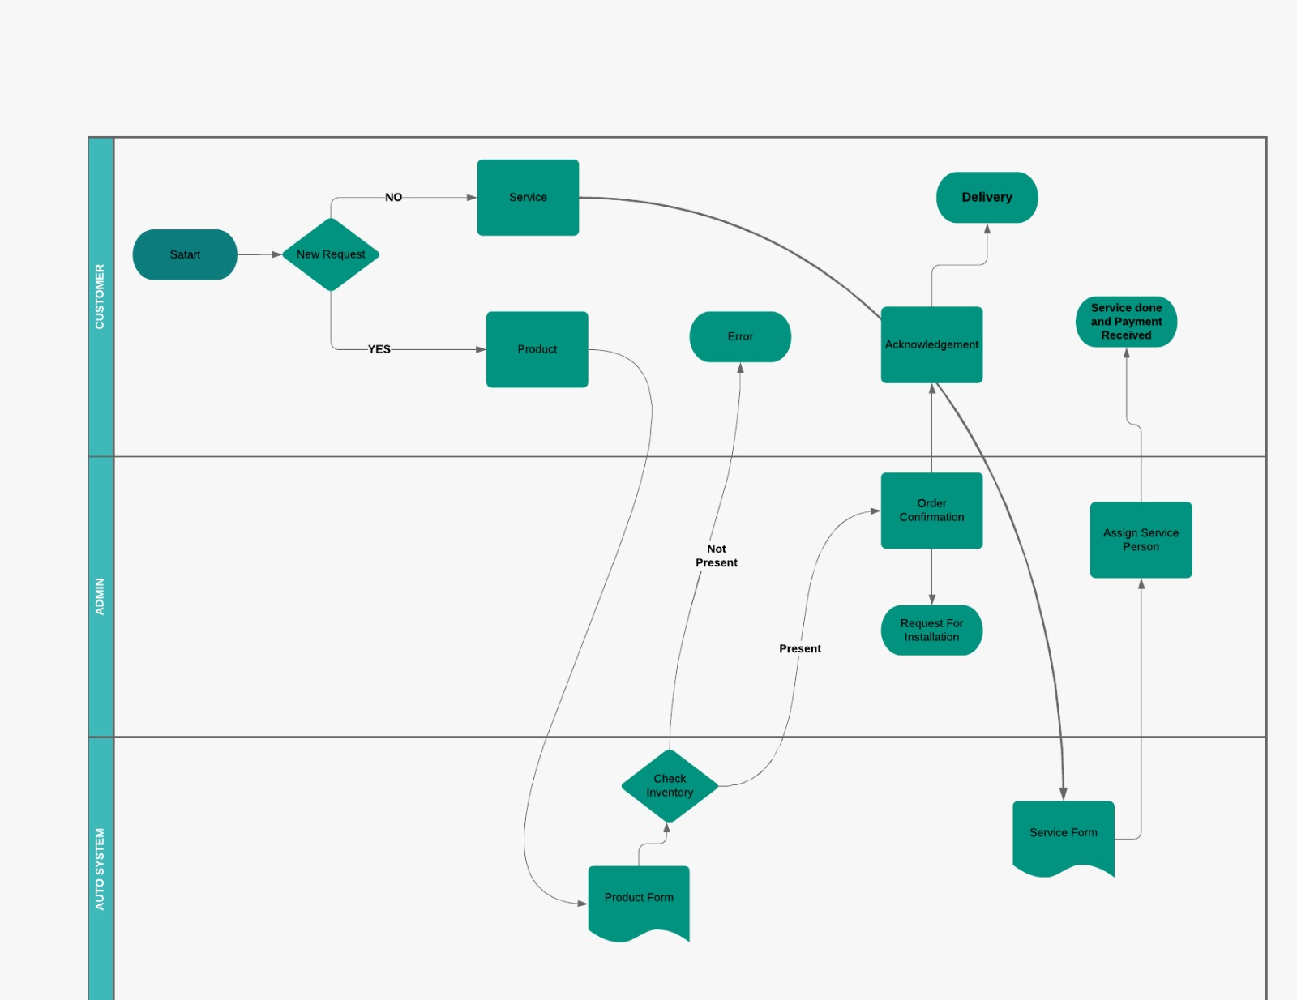

## **Wireframes**

The following screens are the mock screens of the pages that we are going to design using Visualforce.

Wireframe for raising a service request:

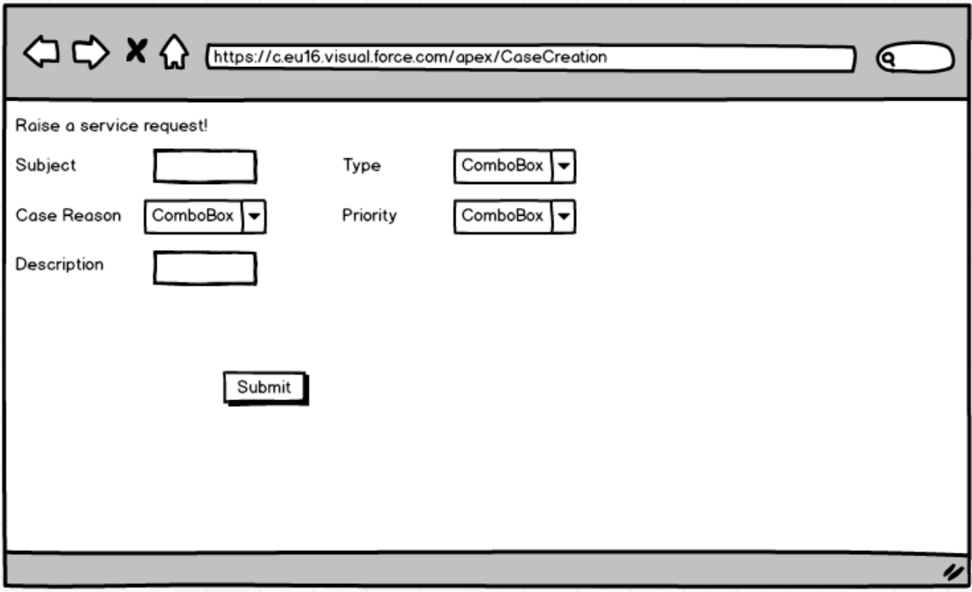

Wireframe for creating a new order:

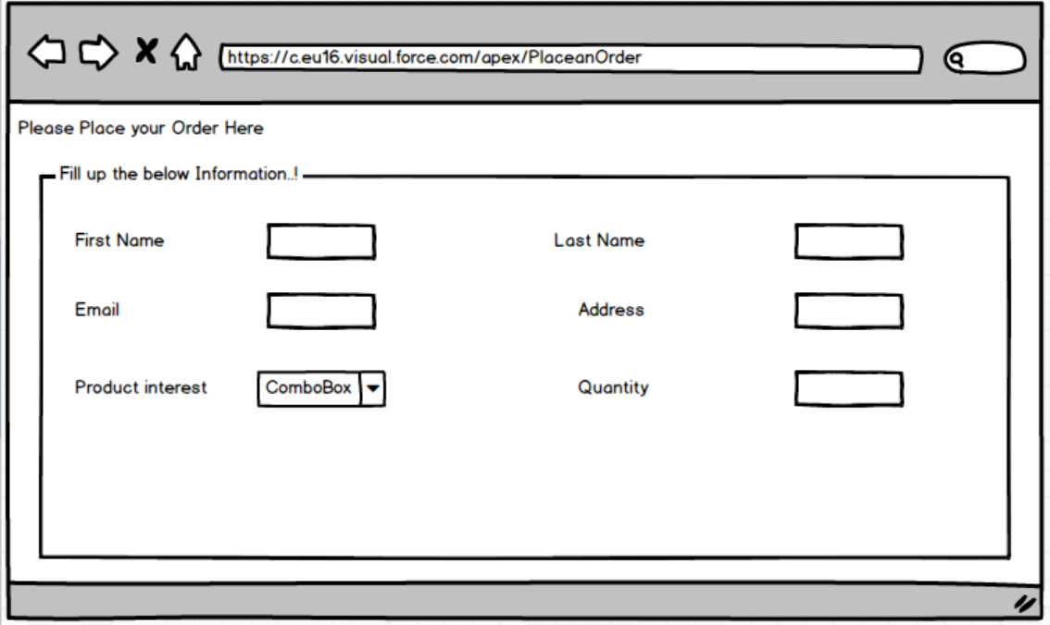

Operational Dashboard Wireframes:

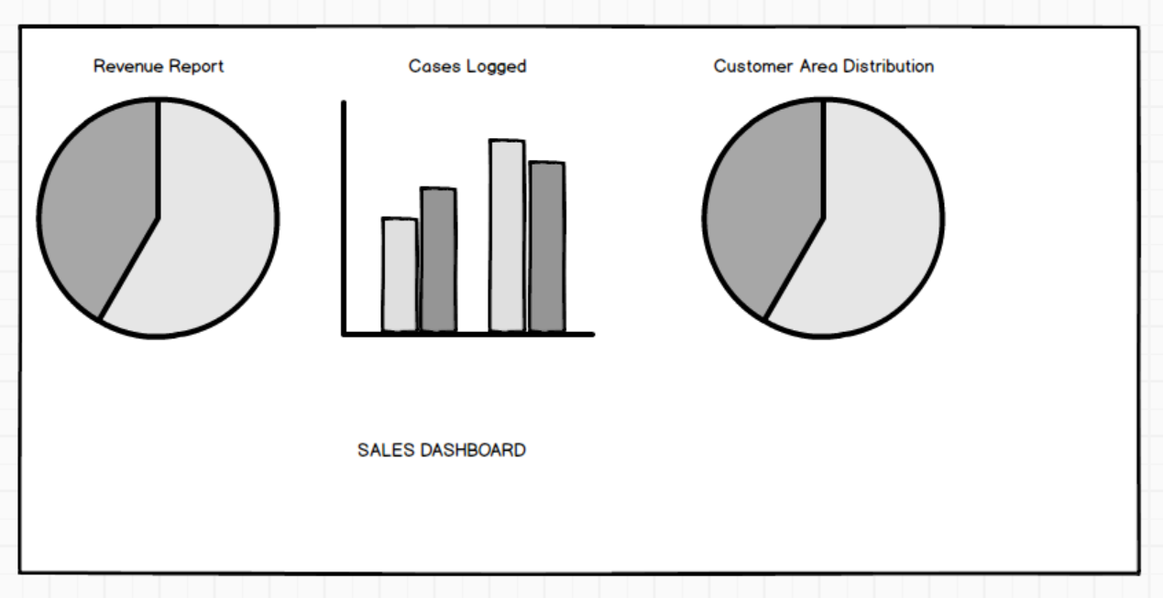

# **5. Database Design**

**5.1 Logical design**

Customers being the prime focus of the business, the CRM logical design starts with gathering the customer information through a webpage and an online form and saving it in the database. These details would consist of personal data like name, number, email, address etc. The form would ask the customer to select the product/services he/she would require and create a new order for each product/service based requests. While selected the product and/or the installation services, the customer can see the charge associated with the respective products and it’s installation service charge. All these saved data can later be used for further analysis and decision making.

**Architecture:**

1. Organisation: Brink Construction
2. Clients: Customers that require the solar products and its services. The client field would have the following sub information: Customer Name, Customer Id, Phone Number, Address and Email Id.
3. Services: List of services the company provides to its customers. These services would include - Installation, Maintenance and repair.
4. Orders: List of the orders made by different customers. This list would include columns like - Customer Name, Customer Id, Order Id, Order date, Products/service requested for.

**Business rule:**

This contains the integrity constraints on the design. Every customer needs to provide their details before placing an order (number and email Id should be active and authentic). After every order is placed, an automated generated email is sent to the customers email Id so that they have a proper record as well (Important if someone else places an order on someone’s behalf). All the successful and unsuccessful order information is saved in the database for future analysis.

## **5.2 Entity-Relationship Diagram:**

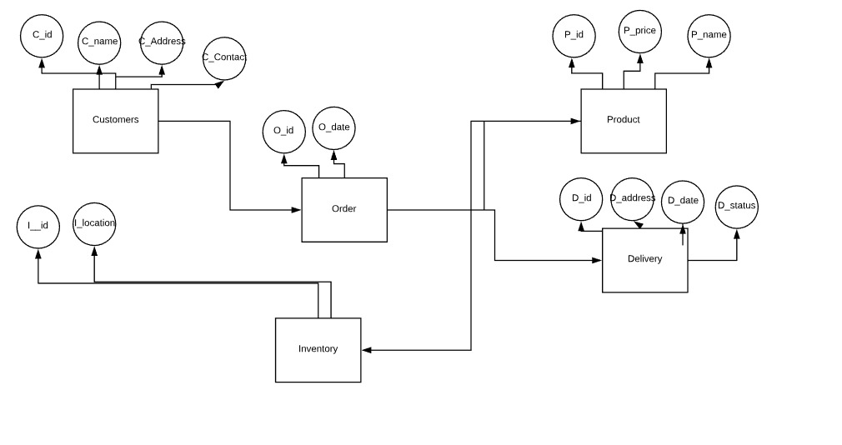

## **5.3 Entity-Relationship Diagram:**

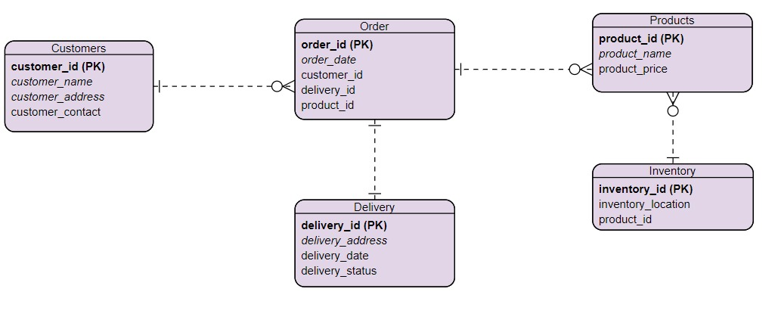

# **Implementation of architecture**

The total architecture of the project has been explained here including the accounts, products, orders, cases etc.

## **Accounts**

The accounts present currently:

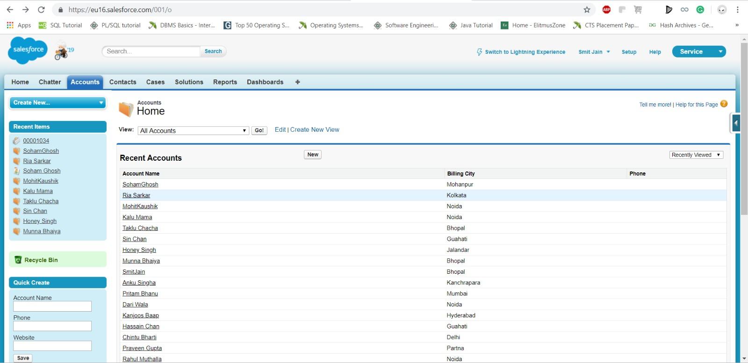

How to create a new account:

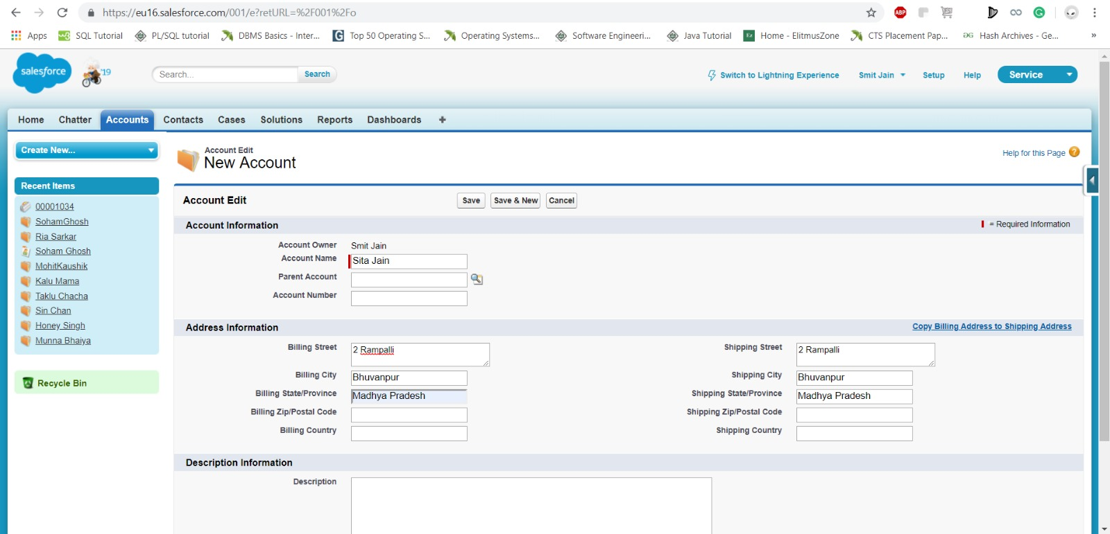

Screenshot of newly created account:

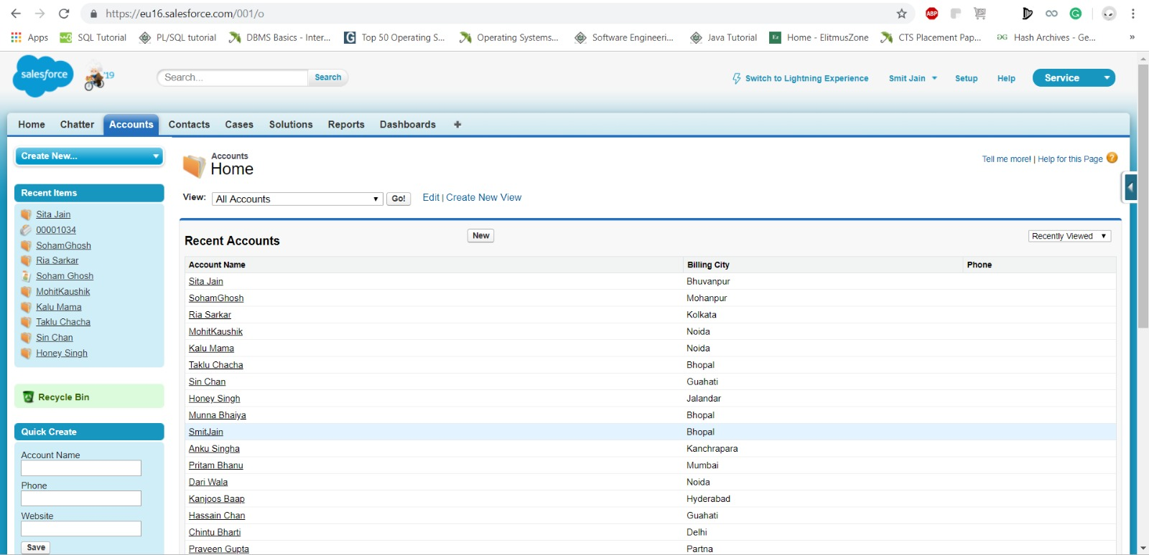

## **Products**

The products present currently:

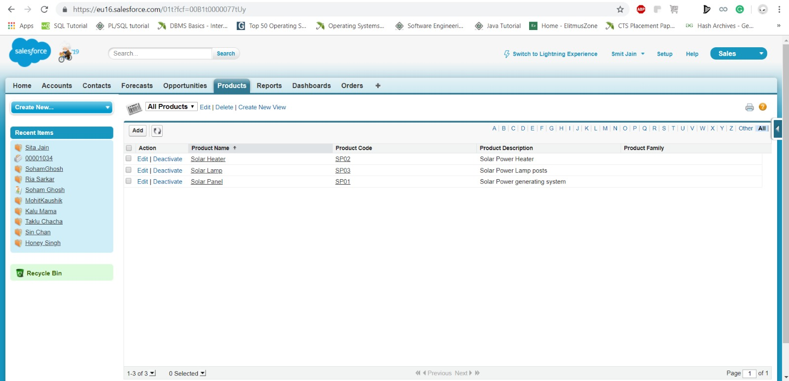

How to create a new product:

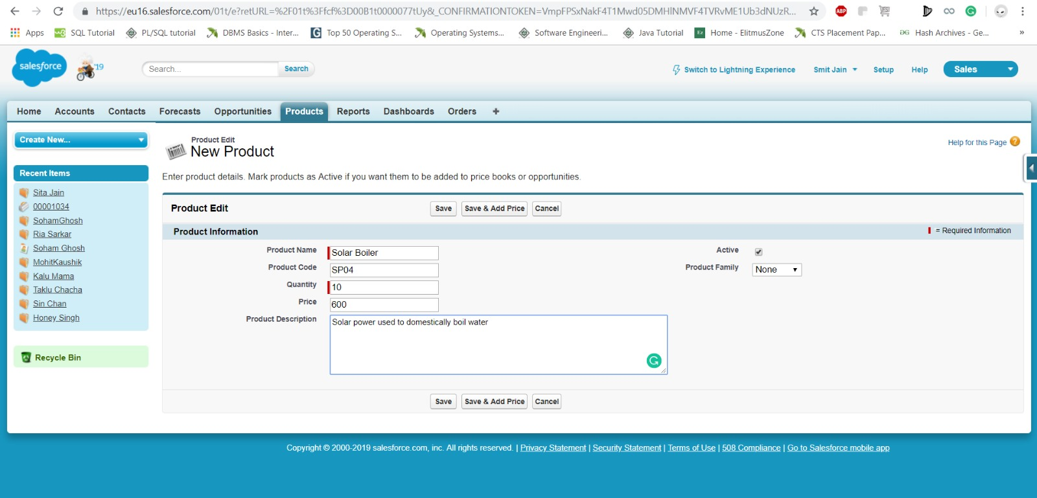

Screenshot of newly created product:

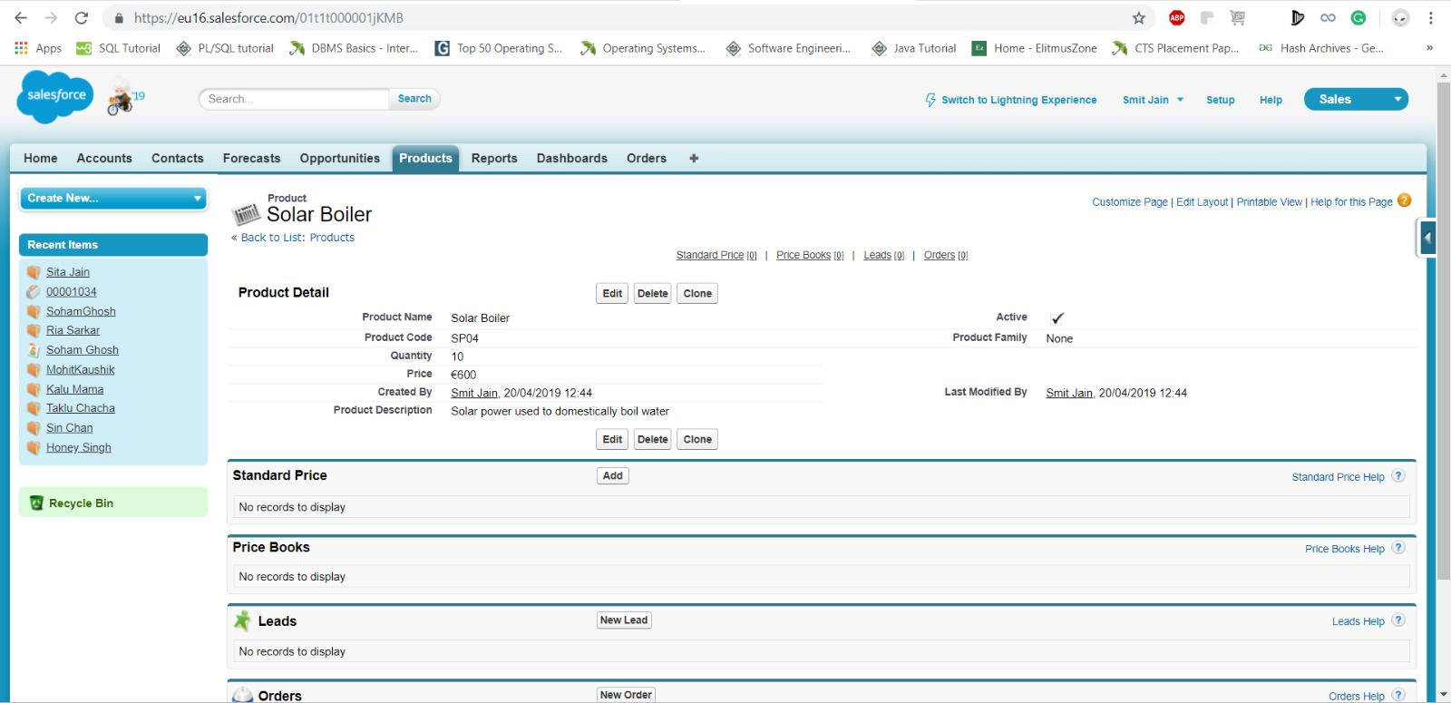

## **Orders**

The orders currently present:

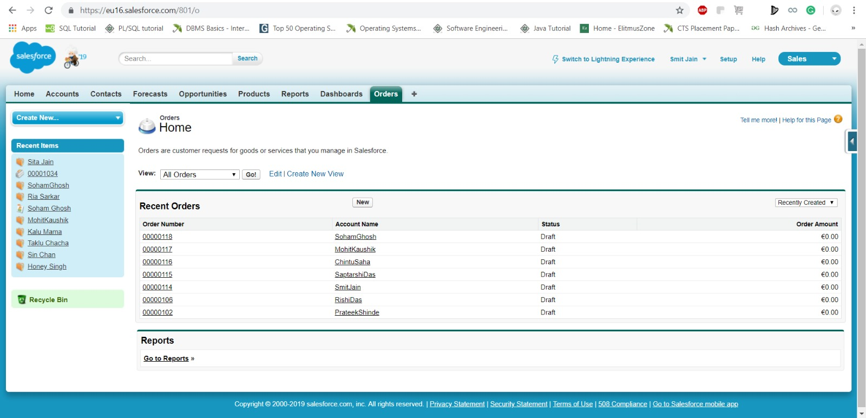

How to create a new order:

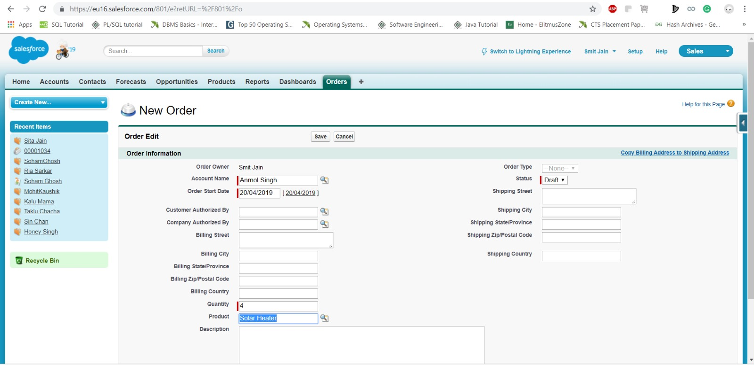

Screenshot of newly created order

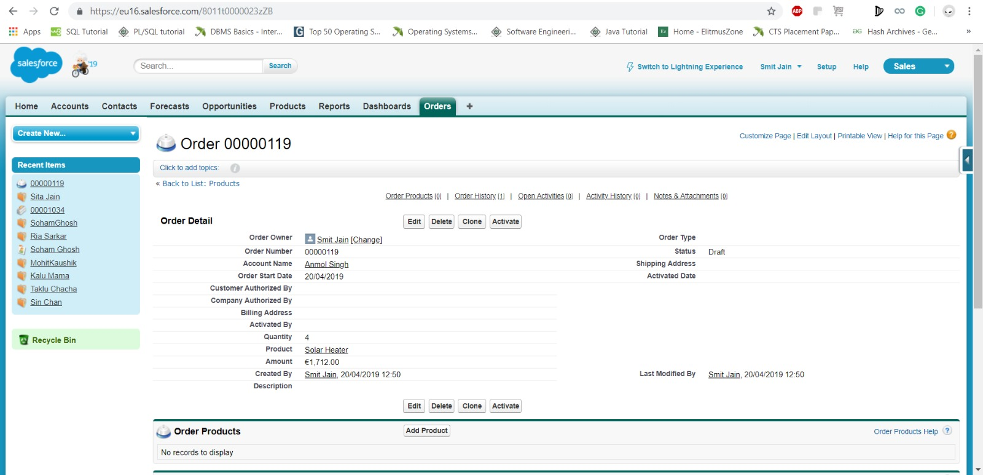

## **Cases**

The current cases:

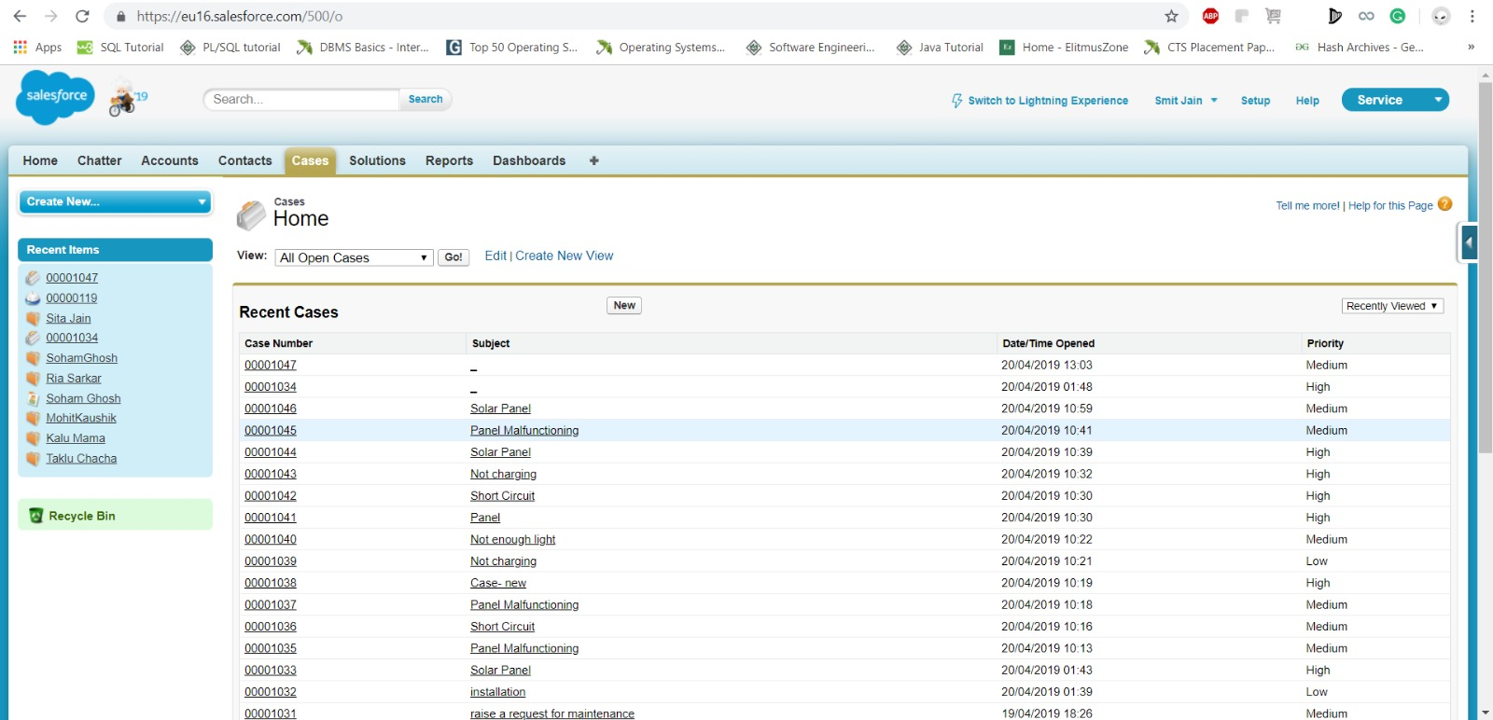

How to create a new case:

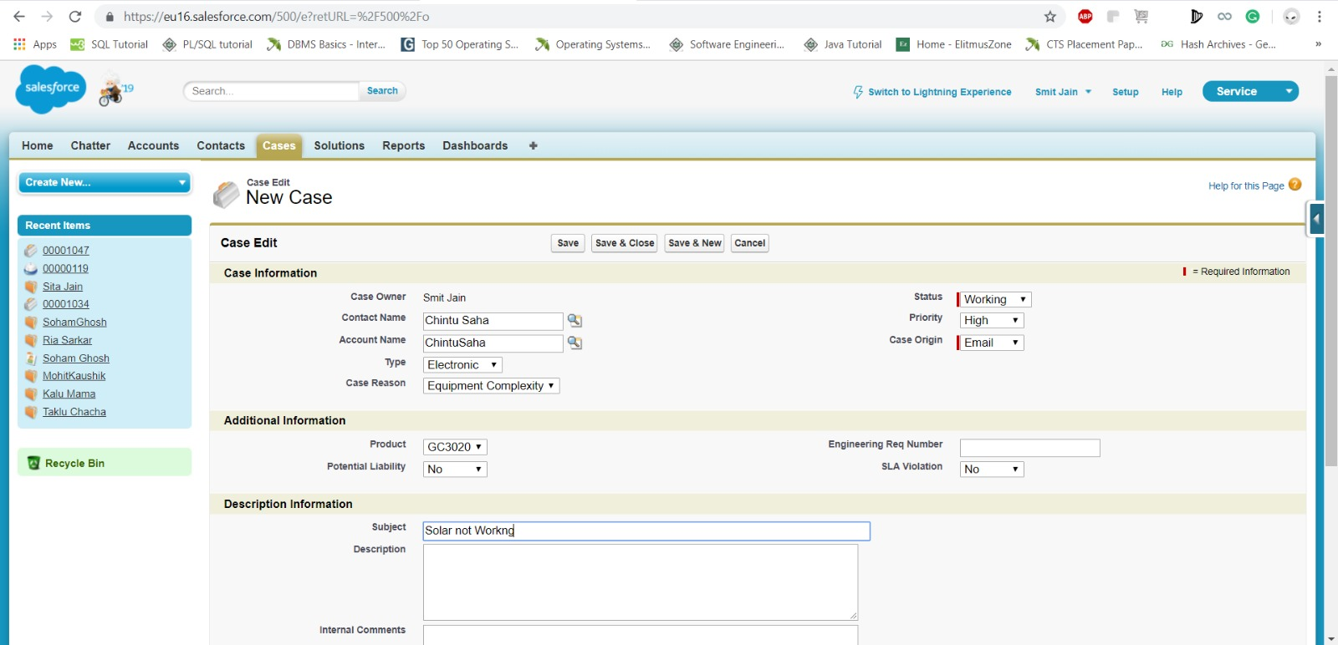

Screenshot of newly created case:

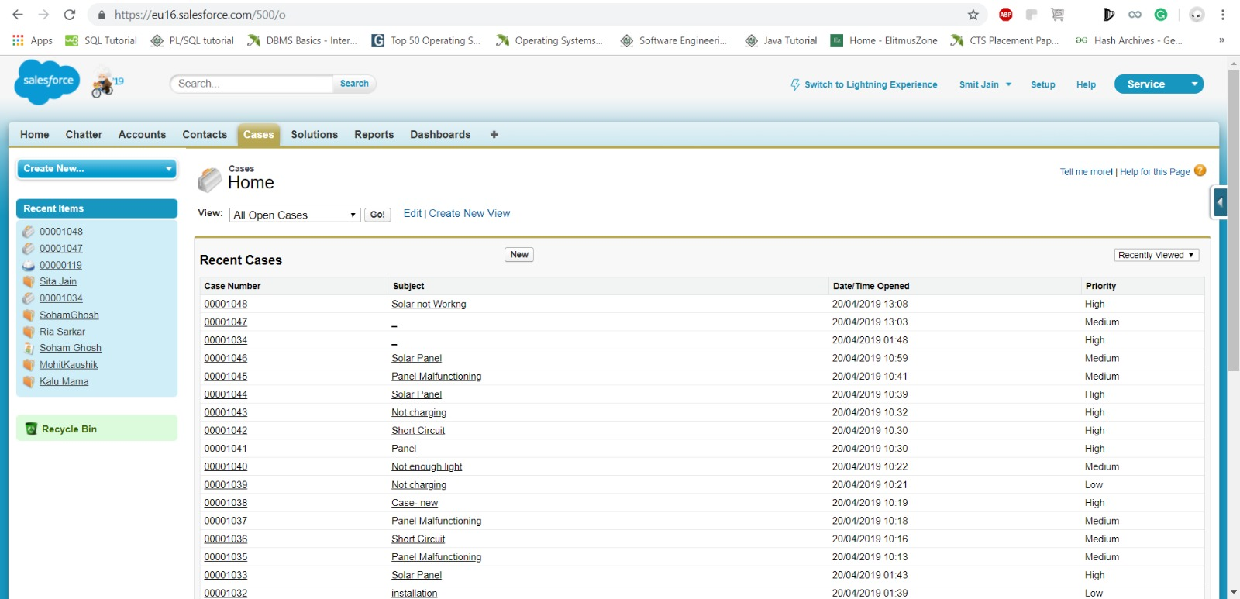

# **Screenshots from salesforce**

## **Visualforce pages**

We have created 3 Visualforce Pages which are – Place an Order, CaseCreation and ThankyouPage.

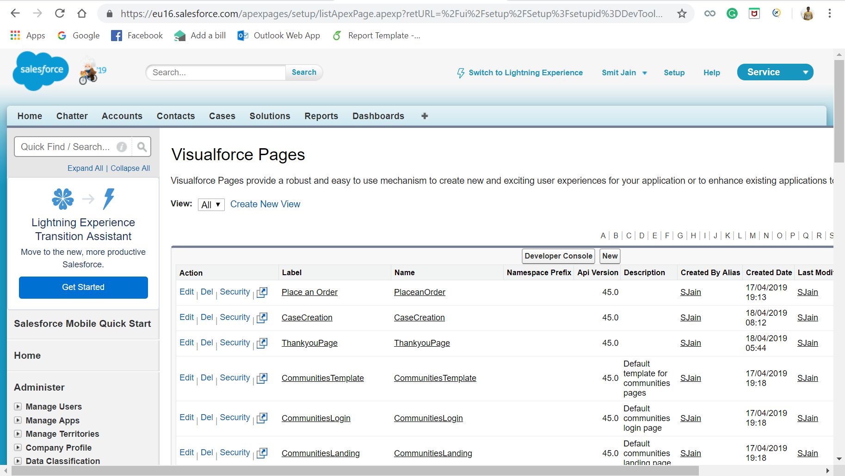

Visualforce PlaceanOrder:

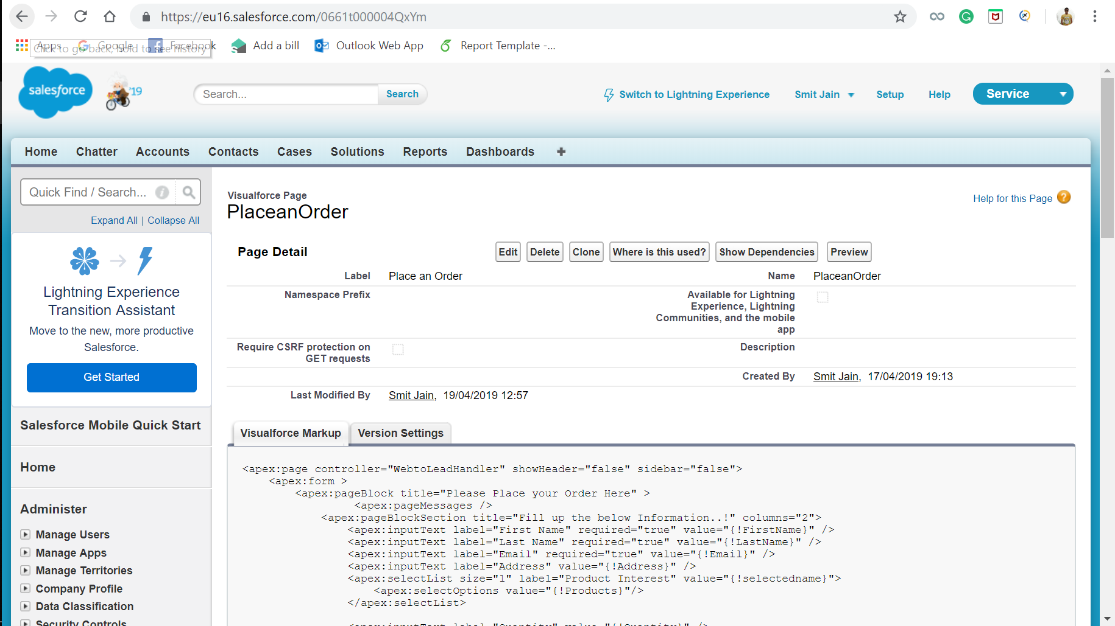

Since the code written for the visual force page is not visible here, we have added it here:

<apex:page controller="WebtoLeadHandler" showHeader="false" sidebar="false">

<apex:form >

<apex:pageBlock title="Please Place your Order Here" >

<apex:pageMessages />

<apex:pageBlockSection title="Fill up the below Information..!" columns="2">

<apex:inputText label="First Name" required="true" value="{!FirstName}" />

<apex:inputText label="Last Name" required="true" value="{!LastName}" />

<apex:inputText label="Email" required="true" value="{!Email}" />

<apex:inputText label="Address" value="{!Address}" />

<apex:selectList size="1" label="Product Interest" value="{!selectedname}">

<apex:selectOptions value="{!Products}"/>

</apex:selectList>

<apex:inputText label="Quantity" value="{!Quantity}" />

</apex:pageBlockSection>

<div align="center" draggable="false" >

<apex:commandButton value="Save" action="{!save}" />

</div>

</apex:pageBlock>

</apex:form>

</apex:page>

Once the order is placed by the customer, an email is triggered to the customer regarding the order confirmation. The screenshot of the email sent to the customer is below:

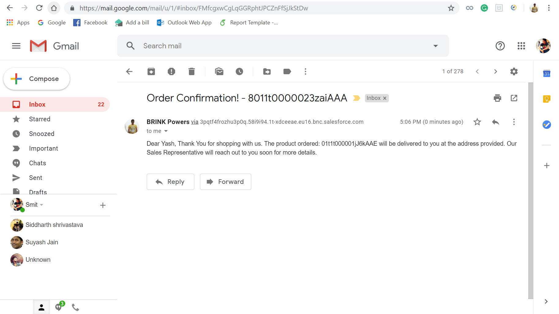

Simultaneously, an email is triggered to the third-party vendor too for the installation of the product the customer has bought.

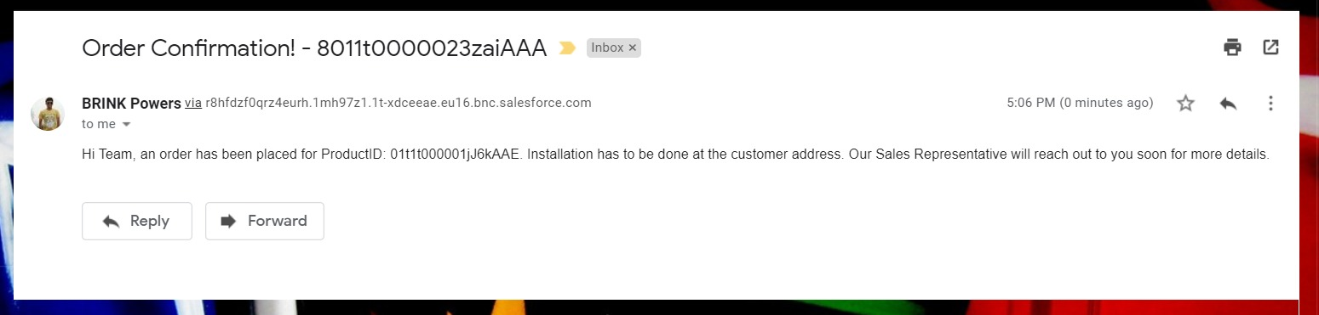

Visualforce CaseCreation:

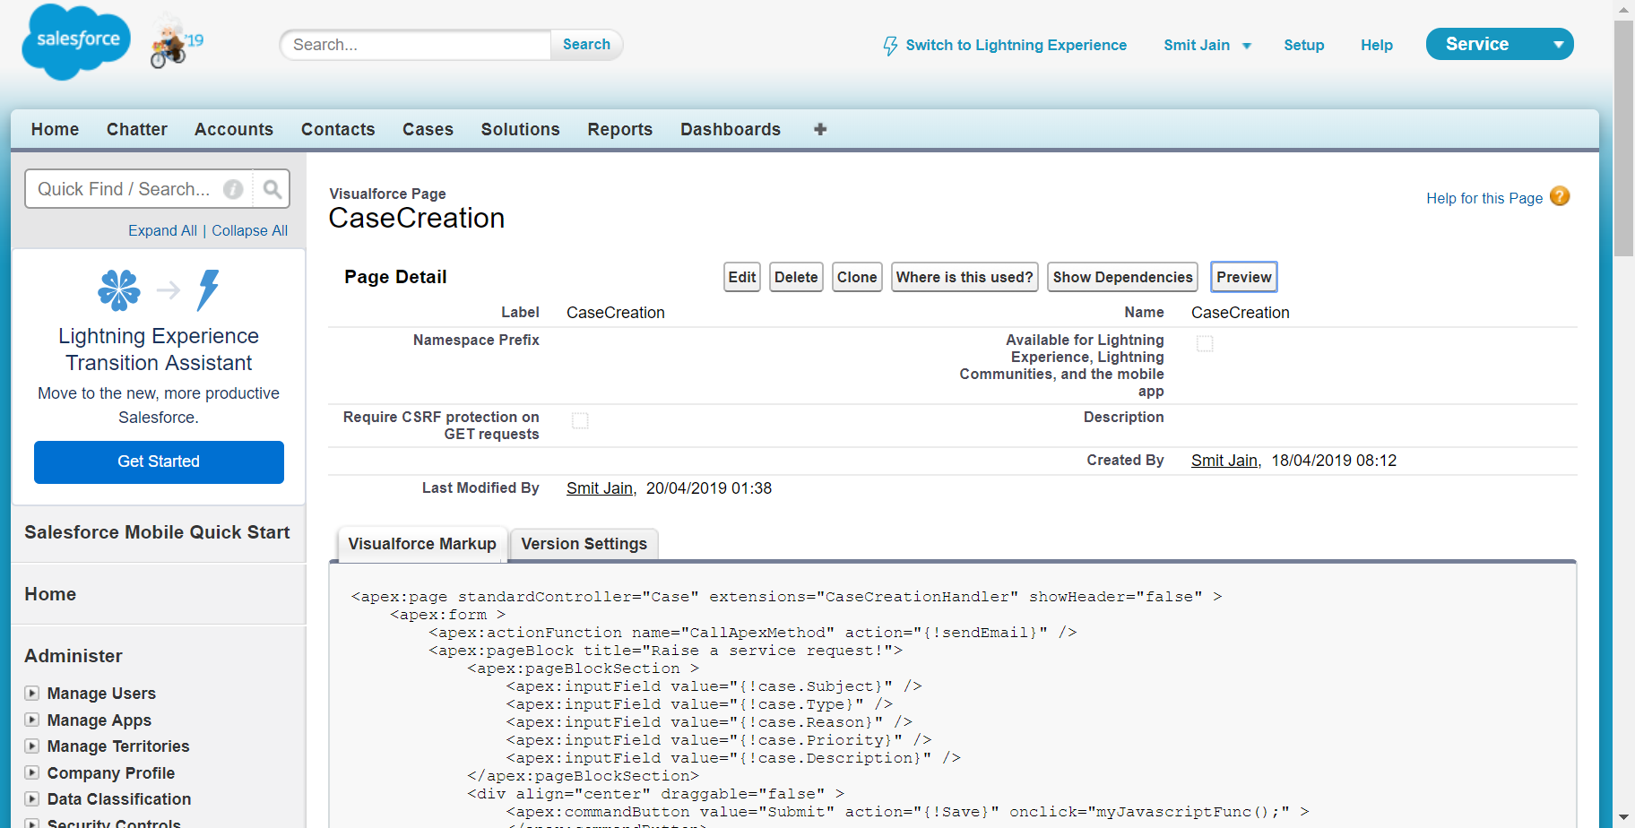

Since the code written for the visual force page is not visible here, we have added it here:

<apex:page standardController="Case" extensions="CaseCreationHandler" showHeader="false" >

<apex:form >

<apex:actionFunction name="CallApexMethod" action="{!sendEmail}" />

<apex:pageBlock title="Raise a service request!">

<apex:pageBlockSection >

<apex:inputField value="{!case.Subject}" />

<apex:inputField value="{!case.Type}" />

<apex:inputField value="{!case.Reason}" />

<apex:inputField value="{!case.Priority}" />

<apex:inputField value="{!case.Description}" />

</apex:pageBlockSection>

<div align="center" draggable="false" >

<apex:commandButton value="Submit" action="{!Save}" onclick="myJavascriptFunc();" >

</apex:commandButton>

</div>

</apex:pageBlock>

</apex:form>

<script>

function myJavascriptFunc()

{

CallApexMethod() ;

}

</script>

</apex:page>

Visualforce ThankyouPage:

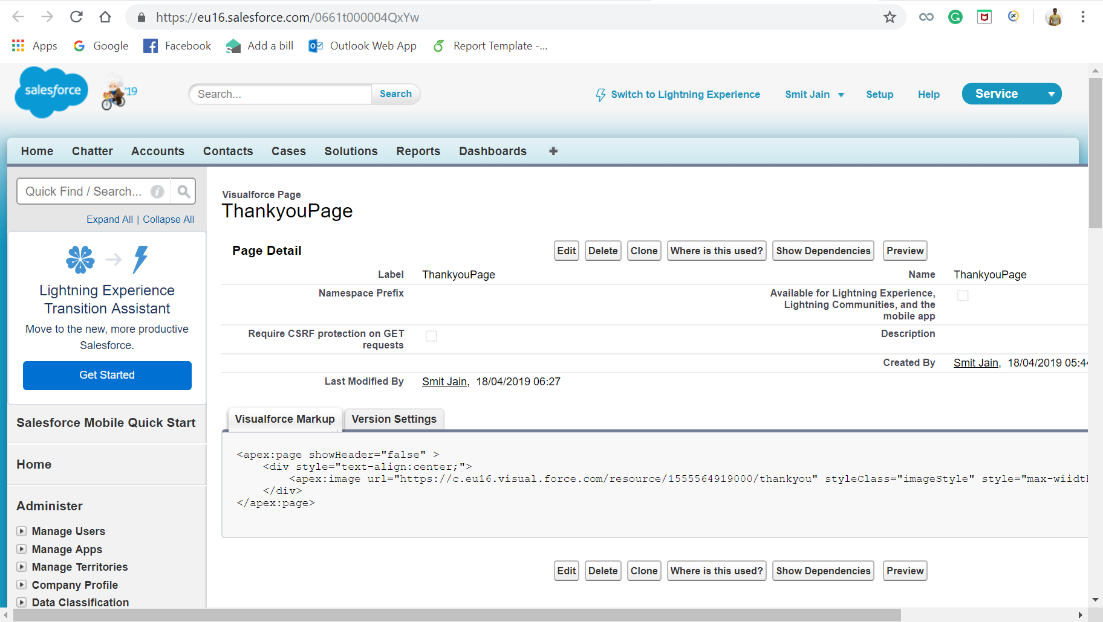

Since the code written for the visual force page is not visible here, we have added it here:

<apex:page showHeader="false" >

<div style="text-align:center;">

<apex:image url="https://c.eu16.visual.force.com/resource/1555564919000/thankyou" styleClass="imageStyle" style="max-wiidth:300px;max-height:300px;"/>

</div>

</apex:page>

## **Apex classes**

Apex Class – CaseCreationHandler:

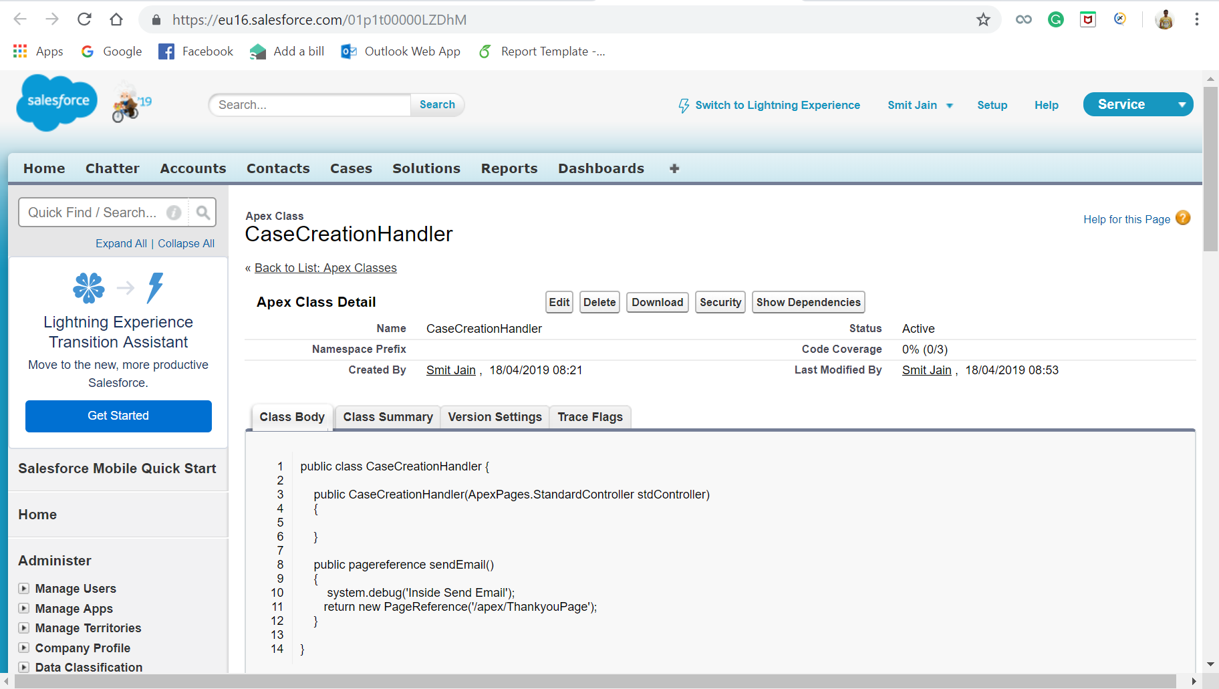

Apex class – WebtoLeadHandler:

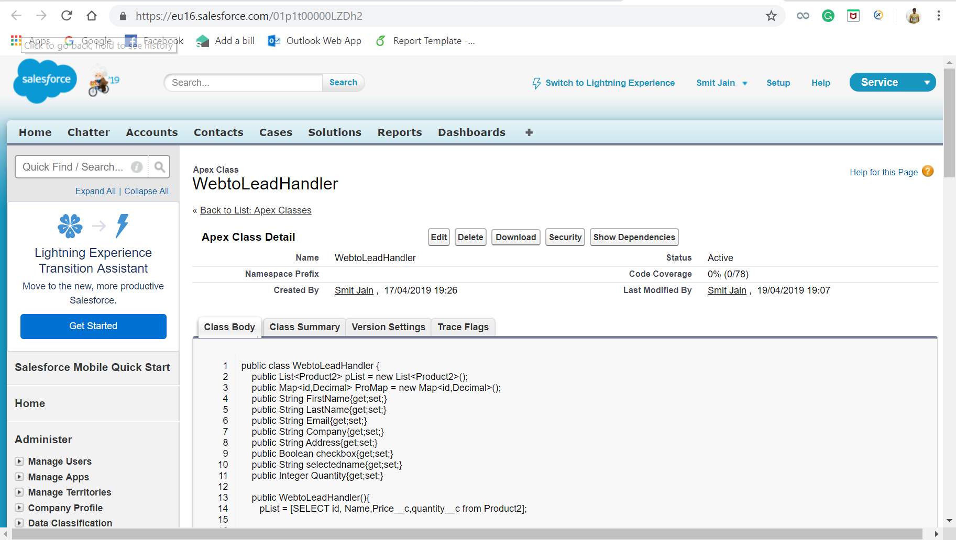

## **Apex class code**

Code for CaseCreationHandler:

public class CaseCreationHandler {

public CaseCreationHandler(ApexPages.StandardController stdController)

{

}

public pagereference sendEmail()

{

system.debug('Inside Send Email');

return new PageReference('/apex/ThankyouPage');

}

}

Code for WebtoLeadHandler:

public class WebtoLeadHandler {

public List<Product2> pList = new List<Product2>();

public Map<id,Decimal> ProMap = new Map<id,Decimal>();

public String FirstName{get;set;}

public String LastName{get;set;}

public String Email{get;set;}

public String Company{get;set;}

public String Address{get;set;}

public Boolean checkbox{get;set;}

public String selectedname{get;set;}

public Integer Quantity{get;set;}

public WebtoLeadHandler(){

pList = [SELECT id, Name,Price__c,quantity__c from Product2];

}

public List<SelectOption> getProducts() {

List<SelectOption> prod = new List<SelectOption>();

prod.add(new SelectOption('','-None-'));

for(Product2 p: pList)

{

prod.add(new SelectOption(p.id,p.Name));

ProMap.put(p.id, p.Price__c);

}

return prod;

}

public pagereference save()

{

if(Quantity > ProMap.get(selectedname))

{

Apexpages.addMessage(new ApexPages.Message(ApexPages.Severity.INFO,''+'Product is not available. Please try after some time'));

return null;

}

contact c = new contact();

c.FirstName = FirstName;

c.LastName = LastName;

c.Email = Email;

c.LeadSource = 'Web';

c.MailingStreet = Address;

insert c;

// Creating Account

Account a = new Account();

a.Name = FirstName + LastName;

a.BillingStreet = Address;

insert a;

// Creating Order

Order o = new Order();

o.AccountId= a.id;

o.EffectiveDate = system.today();

o.Quantity__c = Quantity;

o.Status= 'Draft';

o.Product__c = selectedname;

insert o;

//Decrease Product Quantity

for(Product2 p2 : pList)

{

if(p2.id == selectedname)

p2.quantity__c = p2.quantity__c- quantity;

}

Update pList;

// Send Email to Customer

List<Messaging.SingleEmailMessage> mails = new List<Messaging.SingleEmailMessage>();

Messaging.SingleEmailMessage mail =

new Messaging.SingleEmailMessage();

List<String> sendTo = new List<String>();

sendTo.add(c.Email);

mail.setToAddresses(sendTo);

// Step 3: Set who the email is sent from

mail.setReplyTo('smitj060292@gmail.com');

mail.setSenderDisplayName('BRINK Powers');

// Step 4. Set email contents - you can use variables!

// mail.setSubject('Thanks for registering with us..!');

mail.setSubject('Order Confirmation! - '+o.Id);

String body = 'Dear ' + c.FirstName + ', ';

body += 'Thank You for shopping with us. The product ordered: ' + selectedname ;

// body += '. Our Sales Representative will reach out to you soon for more details. ';

body += ' will be delivered to you at the address provided. Our Sales Representative will reach out to you soon for more details. ';

//body += 'and we will email you your username and password for the community.';

mail.setHtmlBody(body);

// Step 5. Add your email to the master list

mails.add(mail);

Messaging.sendEmail(mails);

// Send Email to Vendor

List<Messaging.SingleEmailMessage> mailVendor = new List<Messaging.SingleEmailMessage>();

Messaging.SingleEmailMessage mail1 = new Messaging.SingleEmailMessage();

List<String> sendToVendor = new List<String>();

String VendorEmail = 'arkaforyou.1611@gmail.com';

sendToVendor.add(VendorEmail);

mail1.setToAddresses(sendToVendor);

// Step 3: Set who the email is sent from

mail1.setReplyTo('smitj060292@gmail.com');

mail1.setSenderDisplayName('BRINK Powers');

// Step 4. Set email contents - you can use variables!

// mail1.setSubject('Thanks for registering with us..!');

mail1.setSubject('Order Confirmation! - '+o.Id);

String body1 = 'Dear ' + c.FirstName + ', ';

body1 += 'Hi Team, an order has been placed for ProductID: ' + selectedname ;

// body1 += '. Our Sales Representative will reach out to you soon for more details ';

body1 += '. Installation has to be done at the customer address. Our Sales Representative will reach out to you soon for more details. ';

//body1 += 'and we will email you your username and password for the community.';

mail1.setHtmlBody(body1);

// Step 5. Add your email to the master list

mailVendor.add(mail1);

Messaging.sendEmail(mailVendor);

return new PageReference('/apex/ThankyouPage');

}

}

# **Test Data**

Steps to add test data to the Accounts:

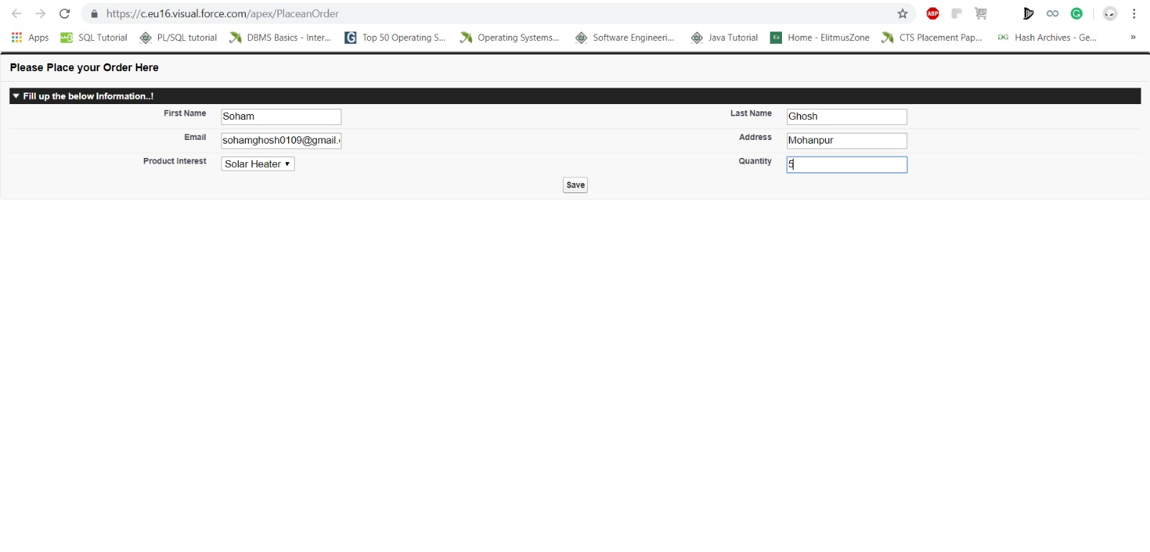

After the customer submits the request, it is redirected to a thank you page:

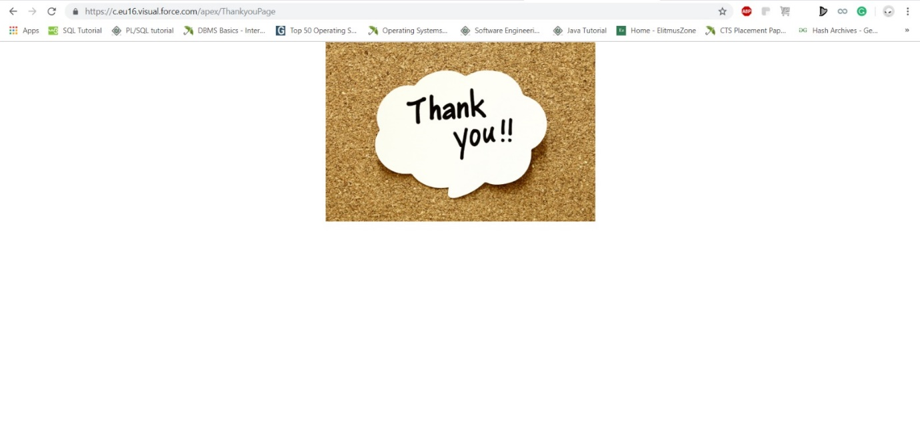

Record added to Accounts:

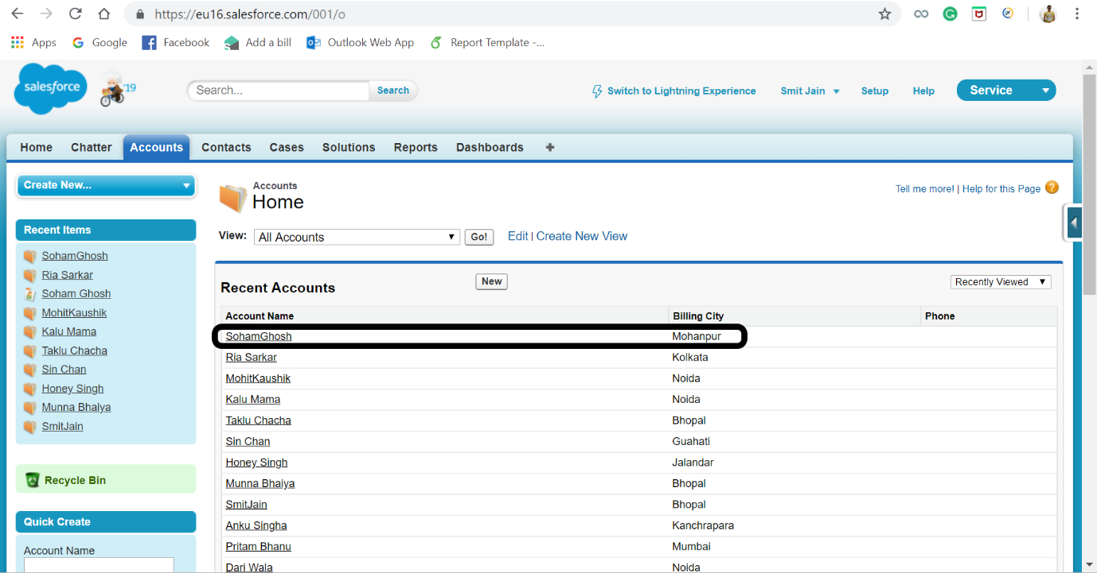

Steps to raise a new service request:

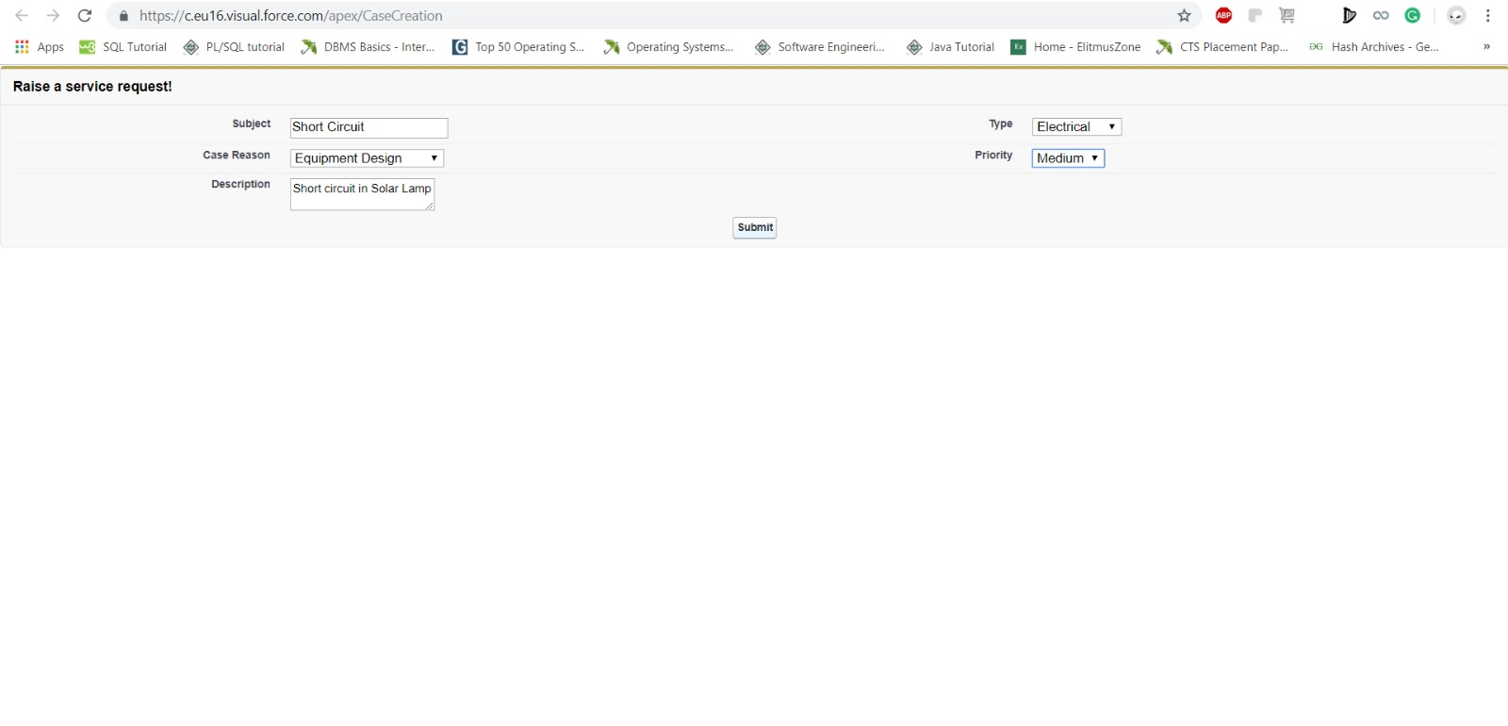

After the customer submits the request, it is redirected to a thank you page:



Record added to cases:

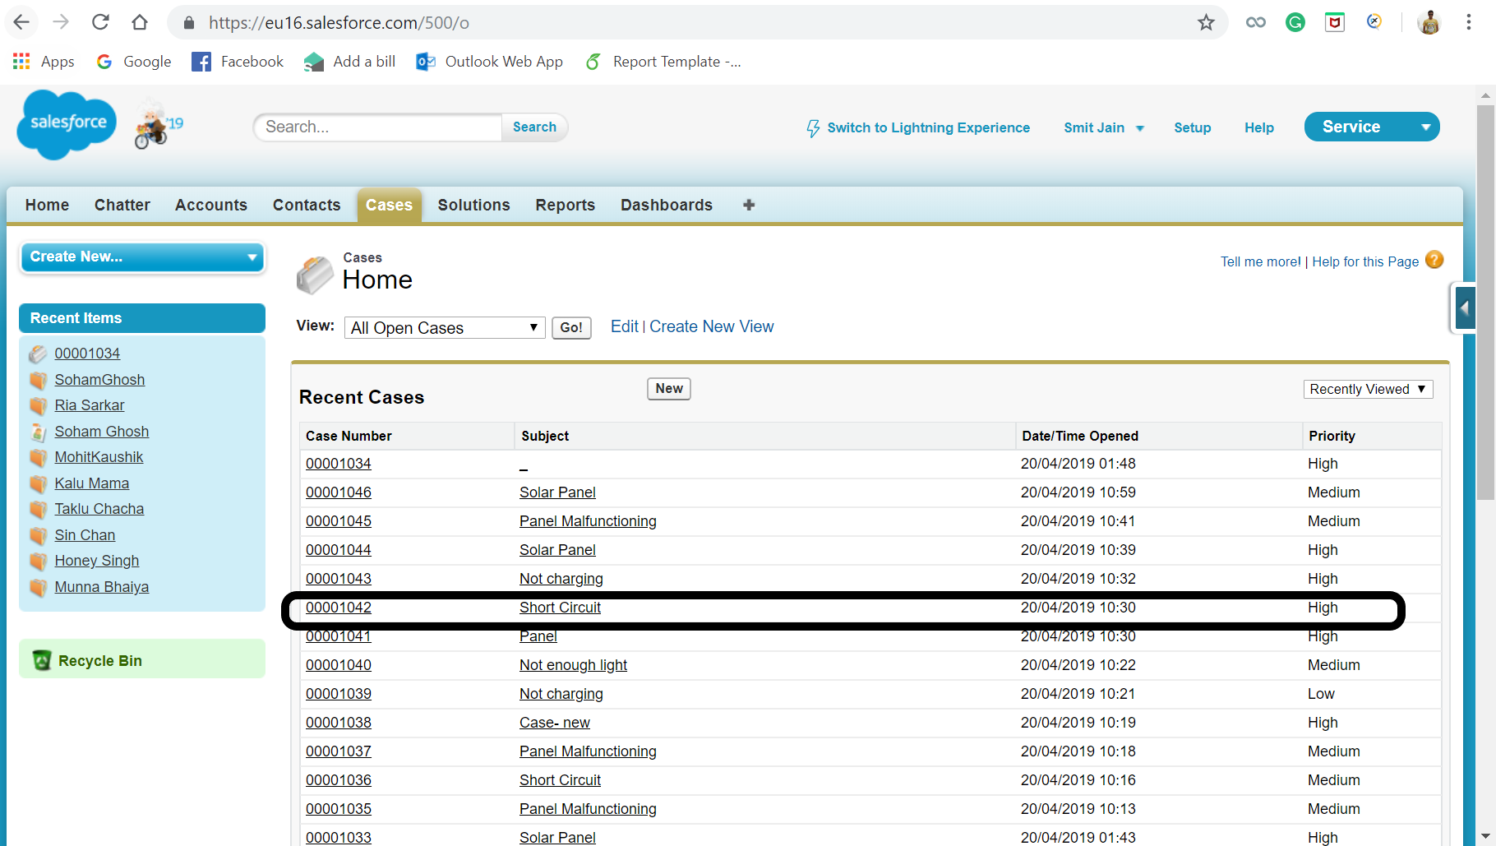

# **Reports and Management Dashboards**

Following are the operational reports and the dashboard created for smooth business process.

## **Operational Reports**

### **Customer report**

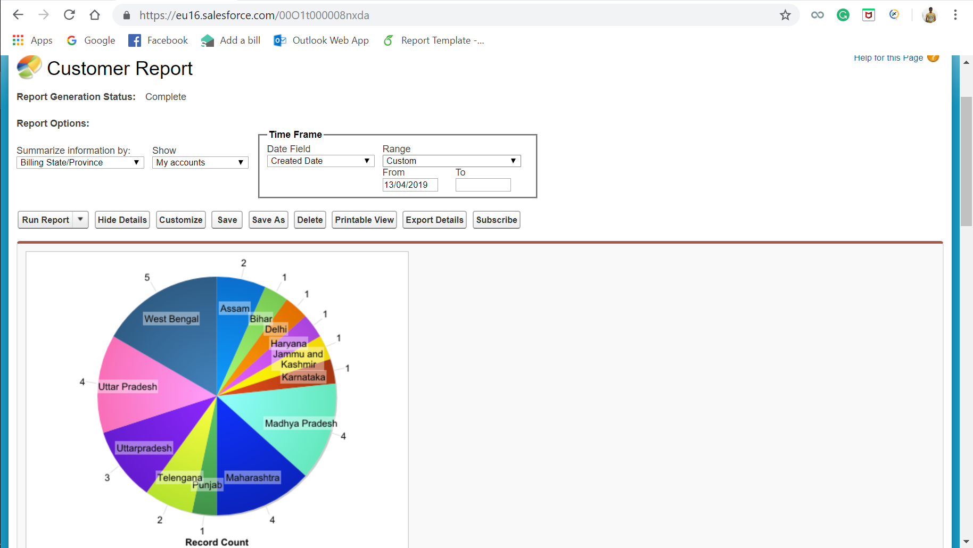

In this report, we can see the customers from different parts of the country. This helps giving an idea about which region is giving more business and which region needs to be looked after for promoting the product.

### **Revenue report**

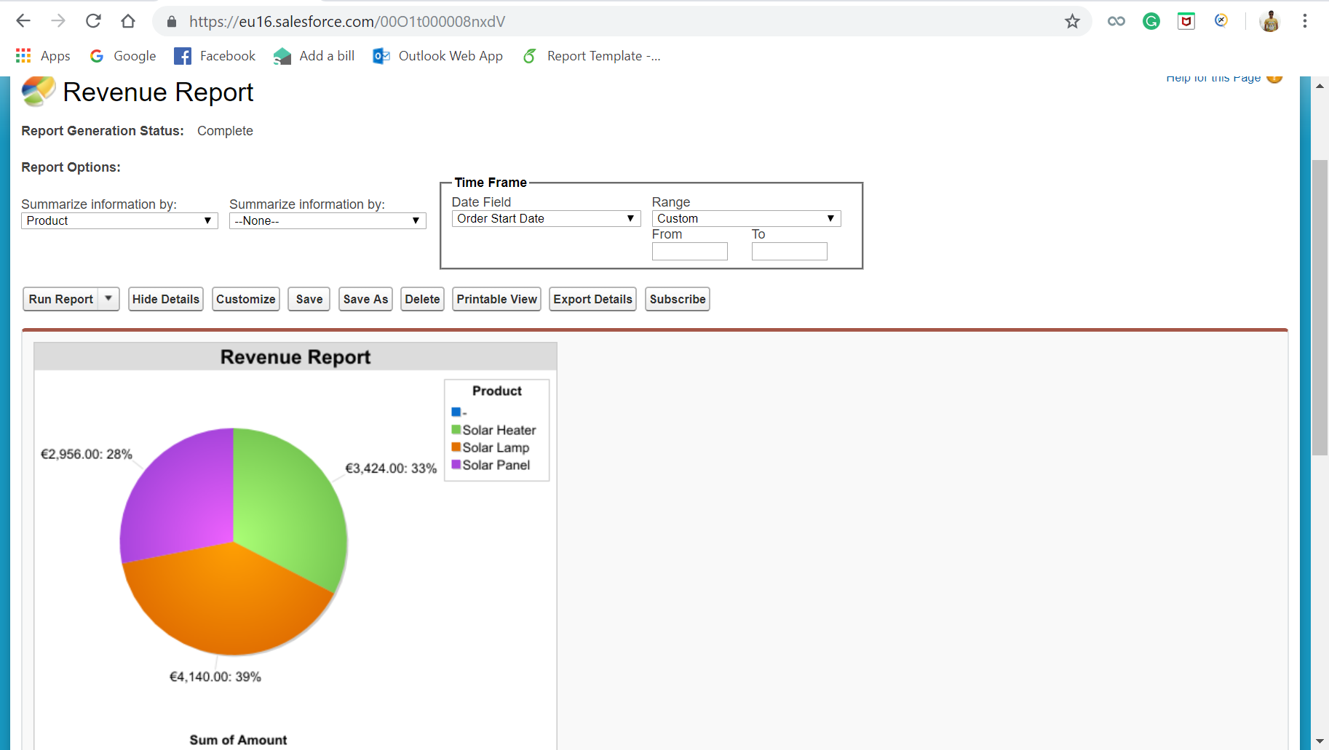

This report gives the stake holders an absolute idea about the revenue generated by each product. This gives an idea to the business about which product needs to be marketed and promoted more.

### **Cases Logged report**

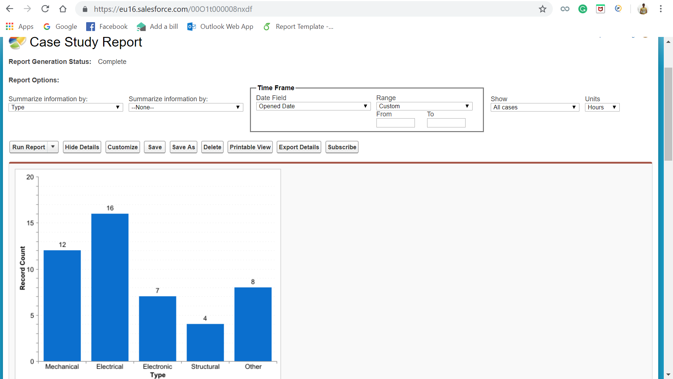

This report tells which type of issues are faced by the customers. Depending on the report, the business can decide and give instructions to the manufacturer to improve the quality of the products that are being manufactured.

## **Dashboard**

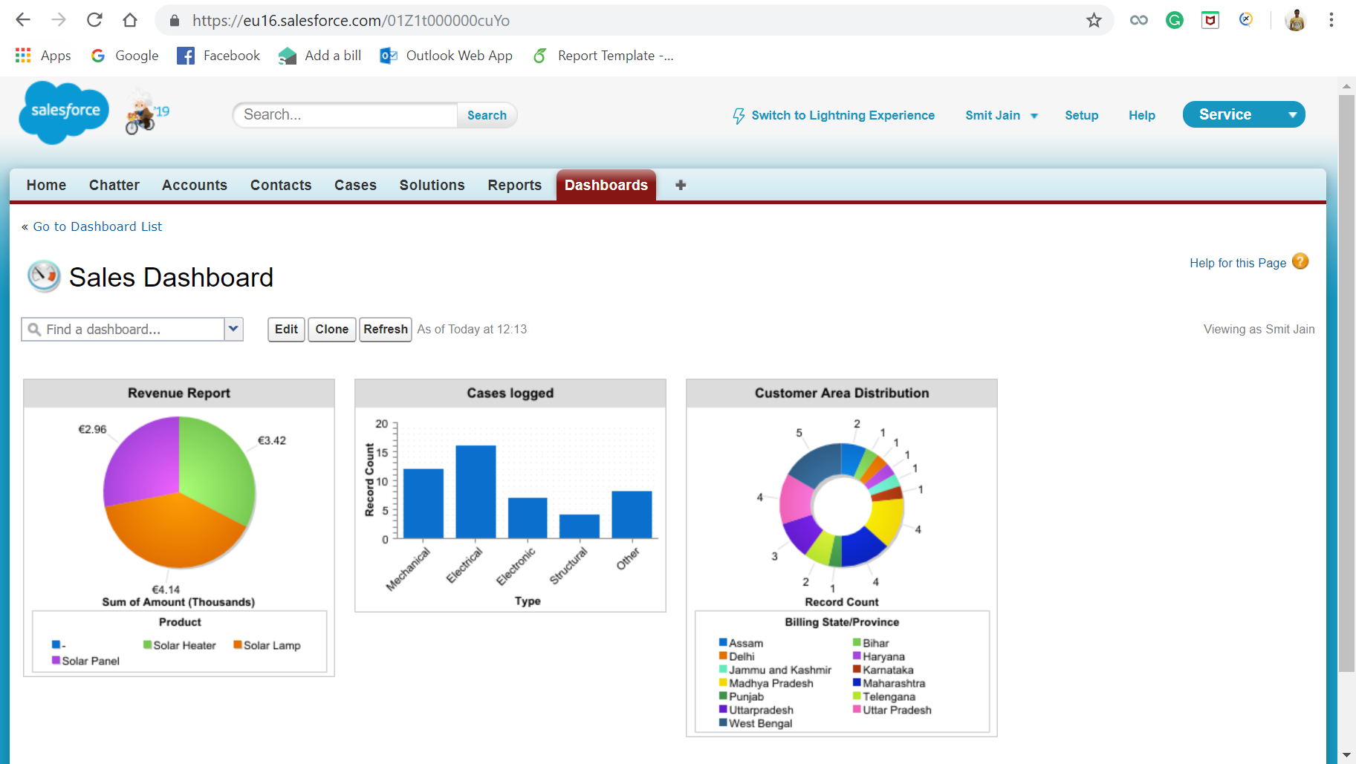

The above figure shows the dashboard which consists of all the three reports lined up in a single page. This makes the stake holders to make a decision easily and swiftly.

# **Conclusion & Prospects**

After implementing CRM salesforce to the existing business, overall performance was Improved as now they had a good platform to improve their customer relations and improve the overall customer database. Analysis could also be done on the historical customer/order data by analysing subject like “which states had the highest number of orders”, “which season/months had the highest solar cells requirements” and “Individuals/Industries of which domain have the highest solar products requirement”. From the analysis we can get to know which State and which product need more attention and in which other states can a new store be opened. So overall, we can say that Salesforce Integrated the whole business workflow.

Due to limited time and resources, we had to leave off certain dimensions of this solution process. In future we can integrate tracking facility of the orders for the customers to self dependently track their orders without taking the hassle to reach out to the organisation. This will save time for both sides. If the Ordered item runs out of stock, we will integrate the facility to notify our suppliers automatically without assigning a particular person to check the inventory every now and then.

# **References**

Indiamart.com. (2019). *Brink Constructions - Distributor / Channel Partner from Malviya Nagar, Bhopal, India | About Us*. [online] Available at: https://www.indiamart.com/brink-constructions/about-us.html [Accessed 20 Apr. 2019].

Tatapowersolar.com. (2019). *Tata Power Solar - Solar Panel and Other Products Manufacturer in India*. [online] Available at: https://www.tatapowersolar.com/ [Accessed 20 Apr. 2019].

Barton, C. (2019). *Which country uses the most solar power? | finder UK*. [online] Finder UK. Available at: https://www.finder.com/uk/nation-most-solar-power [Accessed 20 Apr. 2019].

# **Bibliography**

We have had taken prior confirmation before proceeding on with the view of creating this solution on Brink Powers, proof of which has been attached below.

